Tugberk GOC -- 115200084 --- 22 march 2019

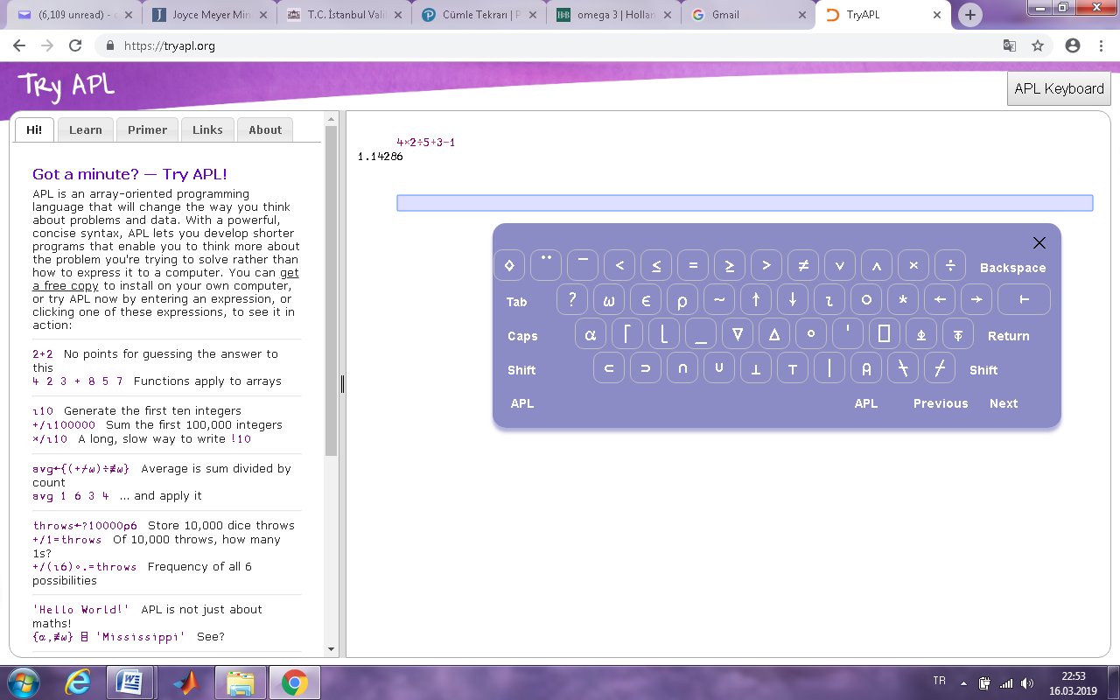LAB EXERCISE – 6 – ANSWERS

1) APL programming language calculates the expressions from right to left sequentially. Calculate the expression below by using a C-based programming language and by using APL (the compiler: <http://tryapl.org/>) Compare and explain the results. (multiplication sign is “x”, division sign is “÷” in APL, use APL keyboard, write the expression in the box as shown on the right side)

|  |  |
| --- | --- |
| a) 10-3+5-2=? | d) for x=3 and y=5 |
| b) 4+2*5=? |
| c) 2*5+4=? |

In APL:

1. 4
2. 14
3. 18
4. 42

In Java:

1. 10
2. 14
3. 14
4. 15.36 (With using double variables)

In APL, it is really new language for me. I calculate with learning syntax on that. I found some results. And, these are calculated by right-to-left. Therefore, I changed my calculations to find same values. Indeed, I haven’t succeed it. I just found the same result for b. Other that that, they are all different. In java, I found right answers with using necessary parameters such as double, int etc.

2) Run the Java code below and explain why result1/result2 are different and why before/after f value are different regarding operand evaluation order.

Answer:

Result1/Result2 :

result1 = (fun1(a) + b) / (fun1(a) - d);

When fun1(a) runs, it returns 17 and also It increases b’s value as 6. Then, fun1(a) runs again, and also this increases b’s value as 8. (Returns 17). D is defined inside the Main. Therefore, it is 12. Calculation is going to be ( 17 + 6 ) / ( 17 - 12) = int(23/5) . It is going to be 4.

After these calculations, we need to realize that: b = 8

temp = fun1(a);

result2 = (temp + b) / (temp - d);

Again, fun1(a) runs, it takes a as 6, then returns 17. And also b is going to be 10.

temp + b = 17 + 10 = 27

temp – d = 17 – 12 = 5

result2 = 27 / 5

result2 must be integer. Therefore, it is going to be 5.

Between result1 and result2, there is only one difference. It is b, because it defined as static. That’s mean, when project runs, it is accessible and changeable from everywhere in the code.

Before/After f :

f = f + fun2();

In above example, it takes static f, then it is going to run fun2(), therefore, it can’t affect by changing f in fun2(). So, static f equals 5 and fun2() returns 6. Therefore, it is going to be 11.

On the other hand, if we evaluate this expression like below,

f = fun2() + f;

It is going to be 12. Because fun2() takes static f and increase by 1, then assign it to itself. So, after fun2(), f is 6. Therefore, we take f as 6. And the result is goint to be 12.

3) Write a Phyton to compare these two divisions ;c=a//b and d=a/b. (// Integer division operator). Assign integer (like a=5 and b=3)and real values (like a=5.0 and b=3.0) to a and b and explain the division results.

a1 = 5

b1 = 3

a2 = 5.0

b2 = 3.0

c1 = a1 / b1

c2 = a1 // b1

d1 = a2 / b2

d2 = a2 // b2

print(c1)

print(c2)

print(d1)

print(d2)

Python 3.6.1 (default, Dec 2015, 13:05:11)

[GCC 4.8.2] on linux

1.6666666666666667

1

1.6666666666666667

1.0

C1 and D1 give the same result. Because in python, If we try to divide some values, it is going to convert values as double to find true solution before user realize that type problems.

C2 and D2:

On the other hand, if we divide with ‘//’ , we are going to find integer value for defined integers. If it is defined double, we just find the same value, but type is going to be double.